Translated from Romanian language to English language
A.O. LEGAL BUSINESS MONITOR
non-commercial organization
Tax code 1022620002351, Legal address MD-2060, mun. Chișinău, str. C.Brăncuși 110, of.18
e-mail: office@legal-monitor.md, www.legal-monitor.md, p. num. +(373) 69 069 529

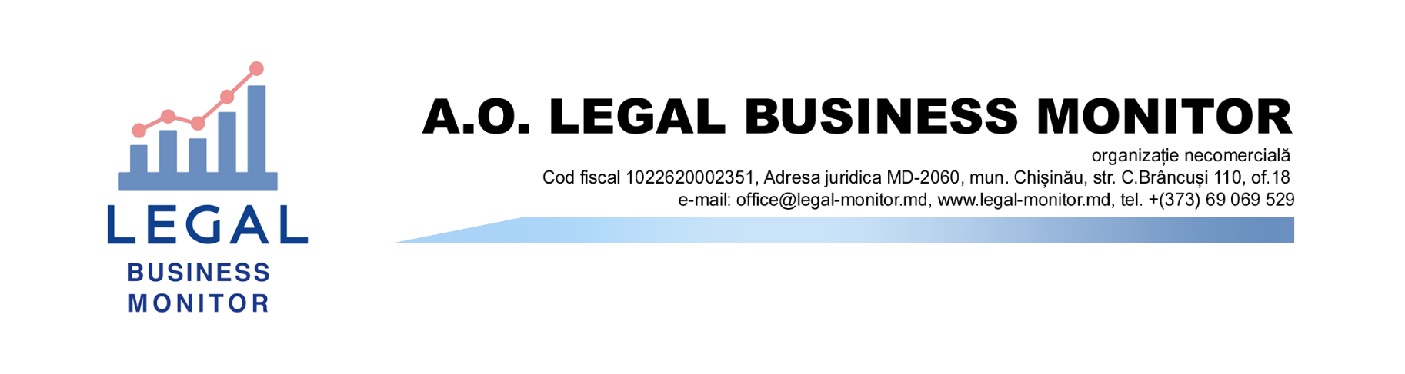
Gambling black market in Moldova exceeded 500 million lei in 2020

The black market of gambling in the Republic Of Moldova, dominated by operators from offshore jurisdictions, has grown steadily in recent years and reached its highest share in 2020, when it exceeded 500 million lei.
This is money transferred by players from our country through payment services (online) to gambling sites abroad, which do not have an activity authorization in the Republic of Moldova. In this calculation, transfers through bank cards were not taken, which means that the final amount may be even higher.
This results from the analysis made by the non-governmental organization Legal Business Monitor based on data presented by the National Bank of Moldova (NBM) and the authorized gambling operator of the Republic of Moldova, NGM Company, the private partner of the National Lottery of Moldova (NLM) in the field of lotteries and sports betting. NGM Company began receiving payments for gambling site www.7777.md, authorized by NLM, from 2019. The share of payments for legal Games was insignificant, compared to the total volume, in 2019-2020.
Table 1
Number and amount of payments received by payment service users
for the category ”games and entertainment”
Year | Number  (million operations) | Value  (million lei)
2018 | 1,23 | 280,64
2019 | 1,8 | 386,97
2020 | 2,32 | 520,47
2021 | 3,15 | 691,6
Sourse: NBM

Table 2
Number and amount of payments received on 7777.md through payment services

Year | Number of operations | Value  (million lei)
2019 | 29 677 | 5,43
2020 | 52 439 | 8,7
2021 | 241 652 | 536
Sourse: NGM Company
The NBM has such information only since 2018, when 1.23 million operations totaling over 280 million lei were carried out. In 2019, the number of transactions increased by almost 600 thousand, and the amount deposited on unauthorized profile sites-by over 100 million lei. In the same period, 5.43 million lei was destined for the legal sector. In the following year, the value of transactions rose to more than 520 million lei, of which 8.7 million lei reached www.7777.md. As a result, companies operating illegally in our country attracted more than 511 million lei from Moldavian players in 2020.
The situation changed the following year, when the blocking of access to unauthorized gambling sites began in the Republic of Moldova in March 2021. In parallel, payment operators also restricted payments for them. The result of these measures is the reduction of up to 155.5 million lei of the amounts directed to organizers of illegal online lotteries and sports betting.
These data were based on an extensive study on the situation related to gambling in the Republic of Moldova and the regulation of the sector, the first of its kind in our country. The research will be made public in the near future.

